**Face Stimuli**

***Trustworthy targets***

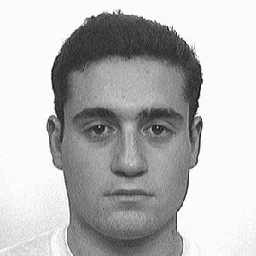

***Untrustworthy Targets***

***Study 1 items***

How much do you think this person is capable of the following (1 = *not at all*; 7 = *very much*):

*Agency traits:*

Planning

Doing things

Having intentions

*Experience traits*

Feeling pain

Having emotions

Feeling sympathy

*Additional items*

Competence

Warmth

Trustworthiness

Dominance

***Study 2 items***

How much do you think this person is capable of experiencing the following (1 = *not at all*; 7 = *very much*):

*Positive primary emotions*

Attraction

Pleasure

Surprise

*Positive secondary* *emotions*

Contentment

Compassion

Serenity

*Negative primary* *emotions*

Anger

Disgust

Fear

*Negative secondary* *emotions*

Guilt

Shame

Remorse

***Study 3 items***

How much do you think this person is capable of experiencing the following (1 = *not at all*; 7 = *very much*):

*Positive primary emotions*

Attraction

Pleasure

Surprise

*Positive secondary* *emotions*

Contentment

Compassion

Serenity

*Negative primary* *emotions*

Anger

Disgust

Fear

*Negative secondary* *emotions*

Indignation

Bitterness

Contempt

***Study 4 items***

How much do you think this person is capable of experiencing the following (1 = *not at all*; 7 = *very much*):

*Positive/other-oriented emotions*

Compassion

Gratitude

*Positive/self-oriented* *emotions*

Pride

Self-satisfaction

*Negative/other-oriented* *emotions*

Guilt

Embarrassment

*Negative/self-oriented* *emotions*

Contempt

Bitterness